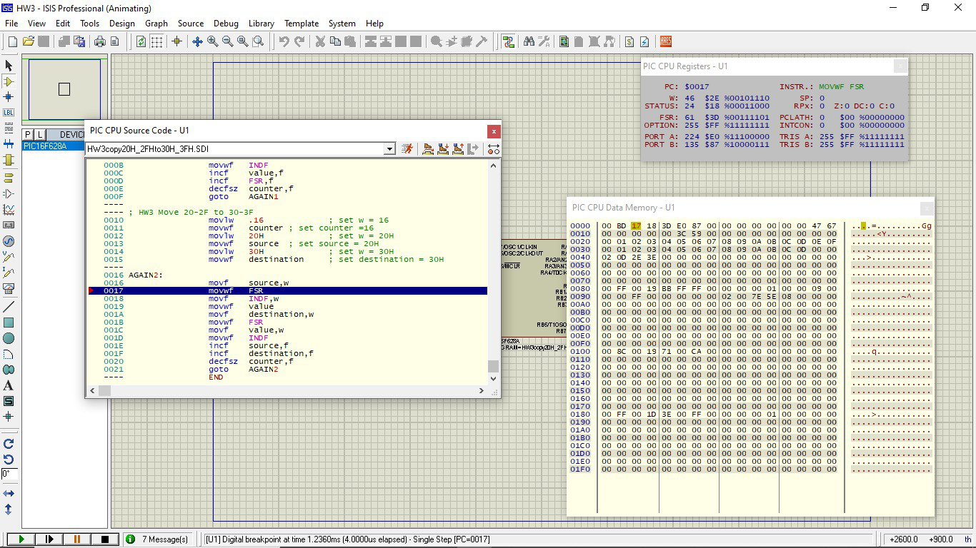

;*************************************************************

;**** Program title: HW3.1 COPY 20H-2FH to 30H-3FH ***********

;**** Programmer: SUPPAKORN HENGPRASITH 5913370 ***********

;*************************************************************

PROCESSOR PIC16F628

#include <P16F628.INC>

__CONFIG _CP_OFF & _MCLRE_ON & _INTRC_OSC_NOCLKOUT & _LVP_OFF & _WDT_OFF

;Declare File register

counter EQU 40H

value EQU 41H

source EQU 42H

destination EQU 43H

ORG 0x00 ; reset vector

**GOTO** START ; jump to start of the program

ORG 0x04 ; Interrupt vector

START:

; SET 20-2F to 0-F

**movlw** 20H

**movwf** FSR

**clrw** ; clrw = movlw 0H

**movwf** value ; set value = w = 0

**movlw** .16 ; set w = 16

**movwf** counter ; set counter =16

AGAIN1: **movf** value,w

**movwf** INDF

**incf** value,f

**incf** FSR,f

**decfsz** counter,f

**goto** AGAIN1

; HW3 Move 20-2F to 30-3F

**movlw** .16 ; set w = 16

**movwf** counter ; set counter =16

**movlw** 20H ; set w = 20H

**movwf** source ; set source = 20H

**movlw** 30H ; set w = 30H

**movwf** destination ; set destination = 30H

AGAIN2:

**movf** source,w

**movwf** FSR

**movf** INDF,w

**movwf** value

**movf** destination,w

**movwf** FSR

**movf** value,w

**movwf** INDF

**incf** source,f

**incf** destination,f

**decfsz** counter,f

**goto** AGAIN2

END

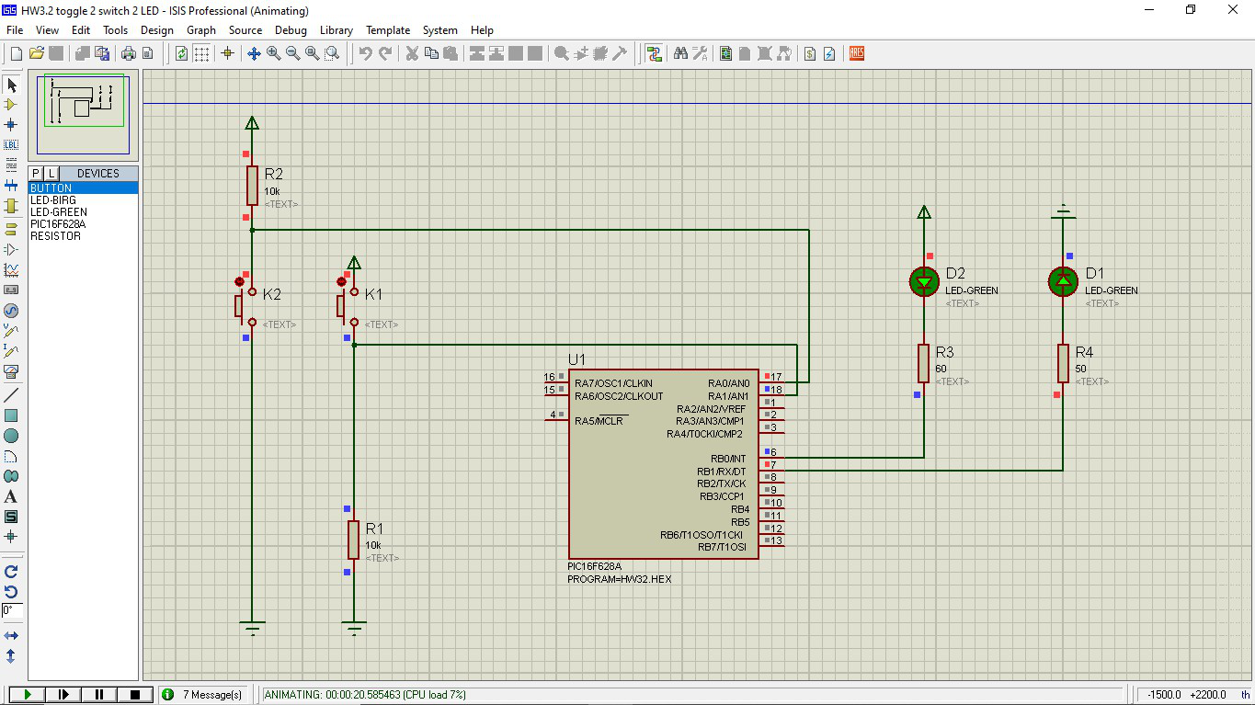;*******************************************

;HW32 2switch2led toggle

;*******************************************

PROCESSOR PIC16F628

#include <P16F628.INC>

__CONFIG _CP_OFF & _MCLRE_ON & _INTRC_OSC_NOCLKOUT & _LVP_OFF & _WDT_OFF

;Declare File register

SW1_STATE EQU 40H

SW2_STATE EQU 41H

ORG 0x00 ; reset vector

**GOTO** START ; jump to start of the program

ORG 0x04 ; Interrupt vector

START: ; Port Configuration

**MOVLW** .7

**MOVWF** CMCON ; CMCON=7 turn-off analog comparator inputs

**BCF** STATUS,RP1 ; or 'BCF 0x03,0x06'

**BSF** STATUS,RP0 ; Select Bank1

**BSF** TRISA,0 ; Port RA0 is an Input pin

**BSF** TRISA,1 ; Port RA1 is an Input pin

**BCF** TRISB,0 ; Port RB0 is an output pin

**BCF** TRISB,1 ; Port RB1 is an output pin

**BCF** STATUS,RP0 ; Back to Bank0

; Start your program here

; K1 ACTIVE HIGH K2 ACTIVE LOW

; LED1 ACTIVE HIGH LED2 ACTIVE LOW

**CLRW**

**MOVWF** SW1_STATE ;set SW1_STATE=0

**MOVWF** SW2_STATE ;set SW2_STATE=0

Inf_loop:

**BTFSC** PORTA,1 ; K1 ACTIVE HIGH use BTFSC

**GOTO** TOGGLE_SW1 ;

RETURN_TOGGLE_SW1:

**BTFSS** PORTA,0 ; K2 ACTIVE LOW use BTFSS

**GOTO** TOGGLE_SW2 ;

RETURN_TOGGLE_SW2:

**BTFSC** SW1_STATE,0

**GOTO** LED1_ON

**GOTO** LED1_OFF

RETURN_LED1_ONOFF:

**BTFSC** SW2_STATE,0

**GOTO** LED2_ON

**GOTO** LED2_OFF

LED1_ON:

**BSF** PORTB,1 ; LED1 ACTIVE HIGH >> on use BSF

**GOTO** RETURN_LED1_ONOFF

LED1_OFF:

**BCF** PORTB,1 ; LED1 ACTIVE HIGH >> off use BCF

**GOTO** RETURN_LED1_ONOFF

LED2_ON:

**BCF** PORTB,0 ; LED2 ACTIVE LOW >> on use BCF

**GOTO** Inf_loop

LED2_OFF:

**BSF** PORTB,0 ; LED2 ACTIVE LOW >> off use BSF

**GOTO** Inf_loop

TOGGLE_SW1:

**MOVLW** .1

**XORWF** SW1_STATE,f ; TOGGLE SW1_STATE

**GOTO** RETURN_TOGGLE_SW1

TOGGLE_SW2:

**MOVLW** .1

**XORWF** SW2_STATE,f ; TOGGLE SW2_STATE

**GOTO** RETURN_TOGGLE_SW2

END